

*[insert your local chapter’s logo here]*

One Struggle,

One Fight

Intersecting Labor and Environmental Movements

Table of Contents

1. An introduction to Earth Strike
2. Climate Change and the Impacts
3. Intersectionality of Environmental Action
4. True Causes of Climate Change
5. The Limitations of Green Capitalism
6. Labour Power
7. A long history of struggle
8. A vision for the future
9. Our demands

An Introduction to Earth Strike

Earth Strike is an international grassroots movement that demands action against climate change from governments and corporations through the tactic of a global general strike. Our planet urgently requires this action to protect it from the impacts of human activity both now and in the future. We recognise that the most severe impacts of global warming affect the working class and poorest people. We are calling on everyone who identifies with those groups, to band together and use our collective power as the majority, to hold to account the industries and governments that continue to exploit the Earth's bounties for their own gains, at the expense of our enduring existence. Our general strike will be held on September 27th, 2019. Two protests will be held globally on April 27th and August 1st to raise awareness in the lead-up to the strike and serve as a call to action for climate justice.

Earth Strike is horizontally organized, decentralized, and is divided into chapters on the international, national, and municipal levels. Local chapters serve to better address the issues within specific areas so that we can take the concerns of many regions into account. Each chapter is an autonomous group of community members, united under the Earth Strike banner and its principles.

We understand that the institutions of production are not adequately regulated by those in power. Therefore, we do not accept that the negligible impacts of personal lifestyle choices are the main cause of our failing planet. Our principles are those of compassion and concern for all because climate change affects us all. It is for this reason that we value a wide range of tactics, and we recognise we will only move forward by reaching out to and collaborating with many local organizations who share the goal of creating a better life for our communities.

Climate Change and the Impacts

Climate change is the phenomenon in which the average global temperature of Earth rises. The science is clear: these dramatic changes are due to human activity and the way that particular industries have conducted production, agriculture, and transportation, especially in the last half-century. It is largely through the burning of fossil fuels, deforestation, and unsustainable livestock farming practices that emissions have steadily risen and have gotten to a point where the Earth is a full degree warmer on average than it was before the industrial age.[[2]](https://docs.google.com/document/d/1yjEnXEcCMXJVDWGUATW6G615NODZNrKZuIMpd2NpWfA/edit#bookmark=id.dkpe21dgt91b) Organic matter and fossils fuels such as coal, natural gas, and oil all produce carbon dioxide when burned. Deforestation inhibits carbon sequestration and the natural flow of the carbon cycle. Because of this, not only is carbon dioxide released when trees are burned to make way for large scale agriculture and the colonization of Indigenous lands, but additionally the planet loses its ability to counteract the carbon emissions, not to mention the millions of species losing their homes. To many, a single degree may not seem like a great deal, but keep in mind that the change between the last ice age (where massive glaciers covered the Earth) to the temperature range we know today is only a four degree difference in average temperature. A single degree or even two degrees means a lot for our world and communities. We are already starting to see the effects today, and we know that there is more to come if we don’t curb our emissions.

The primary cause of the climate change phenomenon is the release of greenhouse gases (GHGs), particularly carbon dioxide, methane, and nitrous oxide, into the atmosphere. When sunlight enters the atmosphere it is trapped beneath the insulation of GHGs and the heat remains absorbed within the atmosphere, soil, and everything on the planet, thereby warming the earth. Greenhouses gases *do* exist in the atmosphere without human intervention and industries and have a tendency to fluctuate. People and animals alike emit carbon dioxide with every exhalation, so when one looks at climate and GHG data, it is important to compare to the pre-industrial averages for temperatures and emissions. Before the industrial revolution and the transition to large scale cattle farming, scientists estimate there was an average of about 280 parts per million units of carbon dioxide in the atmosphere [[11]](https://docs.google.com/document/d/1yjEnXEcCMXJVDWGUATW6G615NODZNrKZuIMpd2NpWfA/edit#bookmark=id.oslx11sy312b), while the most recent official measurement of January 2019 recorded levels of 410 parts per million.[[10]](https://docs.google.com/document/d/1yjEnXEcCMXJVDWGUATW6G615NODZNrKZuIMpd2NpWfA/edit#bookmark=id.zi7vvlxen27b) The concentration of methane, in large part due to the massive rise of factory farming and specifically feeding cattle corn diets, has more than doubled since industrialization.[[1]](https://docs.google.com/document/d/1yjEnXEcCMXJVDWGUATW6G615NODZNrKZuIMpd2NpWfA/edit#bookmark=id.d9rzzwq70nvk) Feeding this rise in concentrations of atmospheric greenhouse gases is ever-increasing fossil fuel use — after three years of stable carbon dioxide emissions worldwide, total annual emissions of carbon dioxide grew by 1.6% in 2017 to 36.2 Gt (billion tonnes), and are expected to grow a further 2.7% in 2018 to a record 37.1 ± 2 Gt CO2 (Le Quéré *et al* 2018b)[[6]](https://docs.google.com/document/d/1yjEnXEcCMXJVDWGUATW6G615NODZNrKZuIMpd2NpWfA/edit#bookmark=id.1adbn6of3x6k).

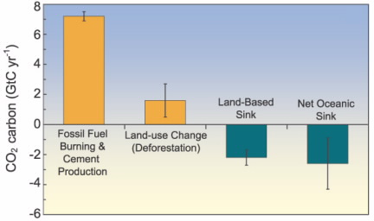

In November of 2018, the Intergovernmental Panel on Climate Change (IPCC), the world’s leading authority in climate science, issued a report stating that we have until 2030 to prevent an increase in average temperature of 1.5° C. After 1.5° C conditions will become completely irreversible and after an increase of 2° C, the planet becomes virtually unlivable for humans and many other species. This is not much time at all, and we must be united globally in order to step up to the challenge and solve these problems. To do this we will have to slash emissions by about 45 percent by 2030. The IPCC report reads:

Pathways limiting global warming to 1.5° C with no or limited overshoot would require rapid and far-reaching transitions in energy, land, urban and infrastructure (including transport and buildings), and industrial systems (high confidence). These systems transitions are unprecedented in terms of scale, but not necessarily in terms of speed, and imply deep emissions reductions in all sectors, a wide portfolio of mitigation options and a significant upscaling of investments in those options (medium confidence).[[3]](https://docs.google.com/document/d/1yjEnXEcCMXJVDWGUATW6G615NODZNrKZuIMpd2NpWfA/edit#bookmark=id.7dxdlgwdbbva)

These transitions mentioned are required to survive as a species and allow ecosystems to restabilise themselves.

Even as we strive to meet these goals, we are faced with the realities of our situation. Climate change is already impacting our daily lives and will continue to grow as a threat: it is the biggest existential crisis of our time. The impacts of climate change are as varied as the Earth itself. They include [famine](https://www.psr.org/blog/resource/climate-change-and-famine/), [droughts](http://www.cgd.ucar.edu/cas/adai/papers/Dai-drought_WIRES2010.pdf), [floods](https://www.nature.com/articles/nclimate1911), [heatwaves](https://www.sciencedirect.com/science/article/pii/S0749379708006867), [hurricanes](https://www.gfdl.noaa.gov/global-warming-and-hurricanes/), [wildfires](https://www.sciencedirect.com/science/article/pii/S0378112709006148), [the spread of infectious disease](http://science.sciencemag.org/content/296/5576/2158), [sea level rise](https://www.nature.com/articles/climate.2010.29.pdf?origin=ppub), and and increase in the severity and frequency of storms and extreme weather. Already we have seen many species go extinct, and many of those (especially insects) are vital to the functioning of ecosystems everywhere. We’ve seen hunger on massive scales because water supplies necessary for irrigation are drying up in lakes around the world, especially in the global south.[[7]](https://docs.google.com/document/d/1yjEnXEcCMXJVDWGUATW6G615NODZNrKZuIMpd2NpWfA/edit#bookmark=id.gn948j1tmvdm) Sea levels are rising due to the melting of glaciers and sea ice, and increased rainfall is drastically changing ocean currents and the migration patterns of many species. Hurricanes Maria, Irma, and even Katrina were a result of and exacerbated by changing climate conditions. Hurricanes are caused by warm ocean water evaporating into the cooler wind creating clouds of great magnitude that become unstable as warm and cold air rapidly circulate amongst the growing clouds and thunderstorm. It is easy to image that as the average temperature of the ocean increases, these changes will have a direct, increasing effect on tropical storms which can often devastate entire communities.

The situation is now truly dire, and without radical action it will only worsen. As the Earth warms, mosquitos and bacteria will be able to move into regions that were once too cold for them to thrive, spreading diseases such as malaria all over the globe. Nearly half of the land surface of the Earth has been transformed by human action; more than half of the freshwater sources are now put to use by human beings.[[7]](https://docs.google.com/document/d/1yjEnXEcCMXJVDWGUATW6G615NODZNrKZuIMpd2NpWfA/edit#bookmark=id.4n2jn36iruks) The species extinction rate approaching 1000-times the “benchmark” or natural rate. It is now expected that by 2070, approximately 30% of all species will be completely extinct.

From the primordial soup, to the ice age, to now, the planet Earth has gone through many changes. We are witnessing one of them, which is in some ways exciting. In the past, life has always continued, despite five major extinction events in Earth’s history. Life on Earth is resilient, and traditionally organisms have been able to migrate to more welcoming environments, and use the process of natural selection to adapt to gradually changing environments. The issue now is that everything is changing too fast, more rapidly than ever before in history; faster than creatures can adapt and migrate as they have done in the past. This new mass extinction is entirely the result of a rigged economic system that plunders natural resources, hoards wealth, and exploits the labour of poor and working people.

Intersectionality of Environmental Action

Environmental movements are necessarily intersectional movements with an eye towards social justice. Intersectionality is the idea that an individual experiences all of their oppressions simultaneously. A black woman is never discriminated against merely as a woman or merely as black person but always as a black woman. Likewise, the way environmental changes affect individuals is dependent on various structural features of that person’s individual identity.

For example, any environmental movement is incomplete without addressing aspects of environmental racism. For decades urban planning has been a tool of the worst kind of social control, creating segregation and slums. Even modern urban planners often use “colour-blind” planning, creating policies which harm communities of colour through negligence and allow established racial inequalities to persist.  Communities of colour and poor communities are also likely to be exposed to a disproportionate amount of hazardous waste. For example, the business owners profiting from building chicken processing plants or power plants in poor communities are not living in the neighbourhoods that have to deal with the waste that plant produces. Often, there are legal sanctions in place to allow for the dumping of toxic waste and dangerous pollutants into minority communities. These sanctions would be prohibited in white, upper-class communities which have the money and social connections to fight them, while disadvantaged groups have no real recourse to protect their communities.

Another prime example of environmental discrimination is seen in the continued colonization of Indigenous communities in the desire for profit from the extraction and transportation of the Earth’s resources. In places such as Standing Rock and the Unist’ot’en Camp, people are battling for their lives and homes against the fossil fuel industry’s demand for a pipeline on their native, unceded lands. The Maori people continually struggle to maintain some sovereignty over their land and resources as developers exploit and damage the ecosystems in which they make their living. The oppression that Indigenous communities face based on the colour of the skin and their heritage is an atrocity, but continues as a persistent systematic method of resource extraction for the accumulation of capital.

Another group that faces large scale environmental persecution is incarcerated people. People in prison are some of the most overlooked when it comes to environmental concerns, as they have virtually no rights to fight for themselves. In the US, prisons are routinely built on top of old landfills. Waste leaks into the water supply, contaminating drinking and bathing water.[[4]](https://docs.google.com/document/d/1yjEnXEcCMXJVDWGUATW6G615NODZNrKZuIMpd2NpWfA/edit#bookmark=id.pnmue62dnoyg) During natural disasters like hurricanes (which are becoming more frequent and more powerful due to climate change), prisoners are some of the last to evacuate, if at all. Many times prisoners have been left for days in flooded cells without food while the guards and caretakers evacuate, leaving them essentially to die. We cannot ignore the fact that the entire prison-industrial complex is built on the backs of racialized communities and the working class. People of colour and people with lower incomes and means are incarcerated at much higher rates than middle class and wealthy white people.

Similar phenomena happen on international scales. United States citizens profit off of the

unsustainable production of goods and we often produce these goods in countries with more lax environmental legislation. The workers in the global south labour to produce goods to be shipped to the United States. Inhabitants of the global south will never even be able to own most of the products they create, or keep the value they produce, but they suffer the most from the negative consequences of such production. Even when the US produces its goods domestically, we often ship our hazardous waste to the global south. The wealth of the world’s empires is built on labour and resources stolen from other countries.

When we analyze the way climate change affects different groups, it is imperative we look at the hierarchies based on privilege and wealth. It is clear that privileged individuals suffer significantly less from the harm of continued exploitation of resources extolls on the environment. When privileged individuals are able to evacuate areas harmed by tropical storms, access to adequate healthcare and shelter, land, education, immediate aid and resources to survive they often remain blind to the fact that people have already died and suffered due to changes in the environment and the implications of climate change for people who have little. Many have died due to respiratory issues caused by climate change, sweltering heat, carbon emissions, and a multitude of other climate related complications. It is often estimated that climate change is killing over 500,000 people per year, yet, because these numbers are limited to those often overlooked who have little to no voice individually, those in power can ignore a mass murder they are ultimately implicated in. Each act of industrialization that brings us further along climate catastrophe can happen quietly without the voices of many rising together in solidarity and struggle. Although most of us individually contribute only a tiny amount to climate change compared to billionaires and industrial corporations, we all have a responsibility to act collectively now in order to end it.

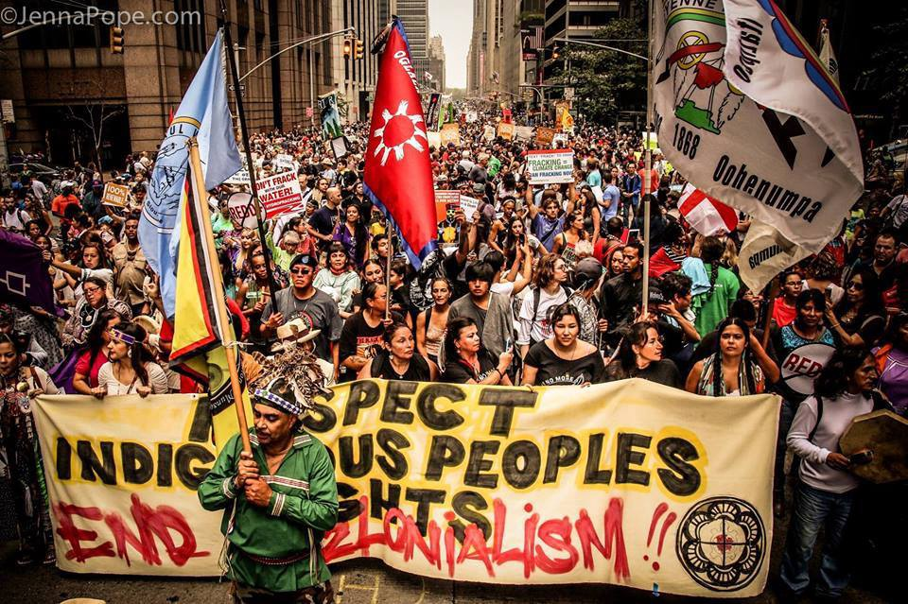

True Causes of Climate Change

Al Gore’s movie and book, An Inconvenient Truth, was published in 2006, and is said to be the primary motivator and wake-up call of the realities of climate change in the last couple decades. While it did serve to open American’s eyes to the importance of climate action, it was and is detrimental to actual climate action in that it places the blame of climate change and the responsibility for change on individual consumers who have little actual power in the industrial system. An Inconvenient Truth highlighted calls to action such as reducing personal electricity use and using electric cars while politely asking politicians to help save our lives. This logic is inherently faulty.

70% of all industrial greenhouse gas emissions are produced by only 100 companies [[5]](https://docs.google.com/document/d/1yjEnXEcCMXJVDWGUATW6G615NODZNrKZuIMpd2NpWfA/edit#bookmark=id.5a7buezdl2rp). These 100 companies are not accountable to the people they are harming and continue to operate, degrading community health and global climate. It is misleading to frame climate change as individual actions or the fault of humanity itself without not only targeting these industries, but also the capitalist system that props them up. There are no individual lifestyle changes that our society can make in order to mitigate climate change to a substantial degree without first changing the system that allows — and even encourages — destroying the life on this planet through profit motive. Many of these lifestyle changes, such as switching from driving to biking or installing solar panels, are also out of the reach of poorer people, further alienating the working class from activism and climate solutions.

Many companies, particularly those in the agriculture and fossil fuel sectors, believe that they have a lot to lose during a transition to a more sustainable mode of production and living**.** When we look to end climate change, we must also seek to transition away from the capitalist system, for they are intrinsically linked together. The capitalist system constantly requires accumulation of wealth to remain viable, forcing price tags into every corner of our lives so that capital can continue to expand. We have seen this through the environment, first with the commodification of land and development of the idea of private property that can be bought and sold. Now water resources are rapidly becoming more privately owned, especially in central and South America, which have been in a water crisis for decades due to the privatization by companies like Coca-cola and Nestle. We see this again in cap and trade programs as an attempt to mitigate emissions. This allows companies to not only buy and sell resources for production but also buy and sell the rights to gradually kill us.

Profit, under the capitalist system, is the end goal in itself, regardless of whether the work being done is actually useful or beneficial to society as a whole. For this reason, we produce significantly more than we need. Humans are constantly facing a barrage of marketing that demands constant consumption of things faster than they can be replaced, from disposable plastics to cigarettes and automobiles. It is this kind of excess that exponentially exacerbates these issues of climate change as more and more fossil fuels are extracted and burned to fuel the production of these goods. This results in a positive feedback loop in that the more people buy, the more power they need to run these things, and the more products people need to buy to supplement an every changing lifestyle in a society that currently fetishizes the disposable and quick-lived.

Another of the major reasons for the ongoing climate crisis is the climate change denial plaguing many politicians and leaders worldwide, but especially in the United States. Beginning in the 70s, Exxon — a top polluter and one half of what is now ExxonMobil — began spending millions of dollars launching climate change denial schemes and lobbying politicians. They payed scientists to publish research sowing doubt about the impacts and causes of global warming, because they knew that if people ever started to find out and take this as seriously as it should be taken, regulations would start limiting their profits. Exxon Mobil began research on climate change and its relation to carbon emissions in the 50s and published a paper in 1957 detailing the link between fossil fuel use and CO2, and was one of the first to do so. Then in the 1970s, James Black (one of Exxon’s researchers) released an internal paper detailing the greenhouse effect of gases and the dire consequences of continuing emissions. A team of major fossil fuel companies, led by Exxon, developed their own task force of industries from the American Petroleum Institute to decide how they were going to handle the greenhouse effect. Almost immediately things became very quiet. Documents and meeting minutes were kept secret, and then Exxon cut its funding for climate research by 600%. A new task force was created called the Global Climate Coalition, with the primary goal of opposing mandatory reductions in Carbon Emissions. They have since been proud advocates of climate change denial. In 1997, CEO Lee Raymond told the 15th World Petroleum Conference that climate change wasn’t happening, and even if it was, fossil fuels weren’t the cause. Though Exxon is one of the biggest players, this situation is not unique. Capitalism values profits over anything else, including the safety and well-being of the world, and before we can begin to tackle the issues of climate change we must understand that. We must ask ourselves: who stands to benefit from our complicity in the system?

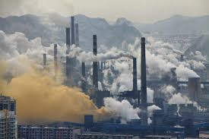

Limitations of Green Capitalism

*“The contradiction between the exploitative organization of society and the natural environment is beyond co-optation: the atmosphere, the waterways, the soil, and the ecology required for human survival are not redeemable by reforms, concessions, or modifications of strategic policy. There is no technology that can reproduce atmospheric oxygen in sufficient quantities to sustain life on this planet. There is no substitute for the hydrological systems of the earth. There is no technique for removing massive environmental pollution by radioactive isotopes, pesticides, lead, and petroleum wastes. Nor is there the faintest evidence that bourgeois society will relent at any time in the foreseeable future in its disruption of vital ecological processes, in its exploitation of natural resources, in its use of the atmosphere and waterways as dumping areas for wastes, or in its cancerous mode of urbanization and land use.” —* Murray Bookchin: Post-Scarcity Anarchism, 1967

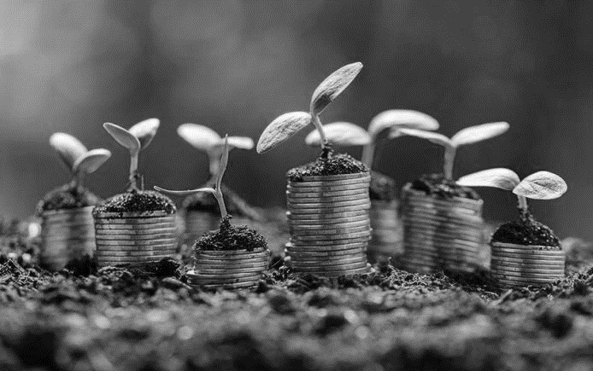

Green capitalism is the idea that market-based solutions from governments and private enterprise can solve the issue of man made ecological catastrophe. While it presents an attractive and painless way forward for stopping carbon-induced climate change through existing political structures, it is severely limited by the contradictions of environmentalism and capitalism that it purports to solve, as well as lacking any challenge to the necessity of natural resource extraction our economic production requires to create growth.

Green capitalism’s weaknesses are the reason for its popularity — the failure to challenge capitalism’s relationship to the environment, and its belief in gradual individualist action to regulate capitalist exploitation of the environment. It lacks any analysis as to how individual actions of the middle and working classes might work against the political and propertied classes. It believes in utopian ideas that businesses will innovate in the environment’s interest instead of innovating to obfuscate and “greenwash” their destructive behaviour, and often puts forward an anti-humanist worldview that fails to consider human interests as equal to the environment’s interests. Proponents of green capitalism rely on good intentions trumping the obvious contradiction between keeping an economic system that demands growth at all costs and the need to severely reduce our resource use.

Gradual transformation of our economies to counter global warming, as sold to us by green capitalism advocates, is insufficient to keep warming below 1.5 degrees. Deep and immediate cuts to industrial emissions are necessary. If those kinds of cuts are made through implementing market-based solutions like emissions trading schemes or carbon taxes, a phenomenon called the carbon bubble may come into effect—fossil fuel assets would see a crash in values, stranding assets and smashing the liquidity of financial markets with huge losses to recoup. The impact on the world economy would be larger than the Global Financial Crisis, with over $4 trillion USD in fossil fuel assets in the firing line.

As we’ve seen, fossil fuel companies and carbon-intensive industries have an incredibly powerful incentive to avoid a carbon bubble and preserve business as usual. They also have outsized influence on the democratic process via their access to governments and ability to advertise whatever message they want to sell. This results in ministers and public leaders watering down and holding back political efforts to curb their emissions, because they want to keep donations coming their way and maintain their future job prospects. The conga line of pro-fossil fuel politicians who walk out of parliaments into plum board positions and executive roles in fossil fuel companies and lobby groups speaks to the powerfully distorting effect of big money upon democracy.

Only through threatening the system with the withdrawal of labour — which creates surplus value for businesses — can we get the transformative change humanity needs for survival. Mass rebellion by working people, through striking and disruption of the economy, is the most effective way to get concessions from capitalists — which is why it is illegal in many places. We need to rediscover class consciousness and recognise that our interests of environmental conservation and maintaining a surplus of means of survival for all people on earth, are in direct conflict with moneyed interests. They want to maintain their wealth and influence within the current status quo, regardless of the impact upon humanity. Only by being willing to directly challenge the system — by acting in an anti-capitalist way — can the green capitalists achieve the transformation they want to see.

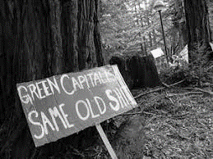

Labour Power

Earth Strike is calling on people of the world to strike for climate justice. The power of the working class will give strength to the movement, by engaging the critical mass of world citizens who earn a wage or salary, to force the hand of the ruling classes that determine how our economies and societies function.

Economies across the globe depend on people selling their labour to produce products, or commodities. Economists since the 13th century have recognised this fact — for example, Adam Smith noted it in ‘*the Wealth of Nations’*, David Ricardo put forward theories to explain how the price of commodities were linked to the labour commanded to produce those commodities, and many later scholars have tried to work out how labour and wages can be predicted or accounted for in the exchange value of products.

Labour is intrinsic to any economic activity undertaken. Even robots need human producers and maintenance workers for when they break; finance industry workers need phones and computers along with their own labour. The withdrawal of labour stops any economic activity eventually. Sustained for long enough, the wealth of the bosses and owners dependent upon the profits of their products will run out of money, subsequently losing their power over wage earners.

The deleterious effect upon society from shutting down our means of survival is obvious. Governments across the world have dissuaded the working classes from taking dramatic strike actions by criminalising different kinds of strike action, to preserve economic stability in their own interests, and that of business owners who require a compliant workforce. The continuing attacks upon the rights of worker unions illustrates the fear bosses have of the power of workers.

Despite some improvements in the prospects of working class people, wealth is more concentrated in the upper echelon of society than at any time for the last 100 years and class consciousness seems to be rapidly fading. Massive systems of production appear to create more stuff for everyone, but workers are worse off, with slipping or stagnant wages and living standards. What has the mooted declassification of our communities brought for the majority of people?

In contrast, direct worker action has a rich history of successful improvements for society. The banning of child labour, the eight hour work day, the two day weekend, the minimum wage, annual leave, and arbitration councils for industrial disputes were all won by labour movements. In the context of grossly inadequate action by the ruling classes to tackle global warming — the most urgent threat to humanity — the same power must be harnessed for our collective survival.

As such, Earth Strike is an expression of the need for climate justice from the vast majority of the world citizenry. Rediscovering the class consciousness that has been destroyed over the last few decades is key to that expression. Young people across the world are already engaging in their own strike actions in schools, leading and providing inspiration for workers who may have felt previously disempowered from individual actions.

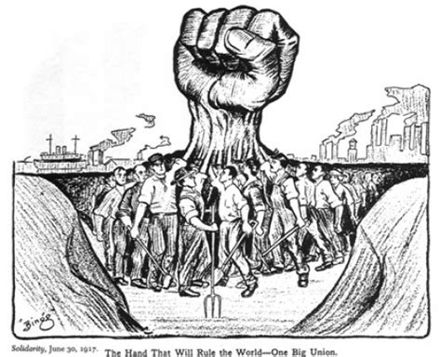

A Long History of Struggle

Our Earth Strike movement seeks to connect two historically large and powerful movements — the environmental movement and the labour movement — into a coalition of people fighting for action to better the world we live in. Throughout history, these movements and activists have both come together for truly positive change and navigated through difficult contentions. In order to unite and fight for the rights of creatures of this Earth, we must realize that these contentions are manufactured by a system that feeds off our own exploitation when we are not unified.

One of the major contentions between labour and environmental organizations first occurred in the 1970’s, when businesses began to see profits in outsourcing labour overseas. Many unions and labour activists feared for the people they represented as industries moved overseas and took jobs with them. They blamed environmental organizations for the shift, based on the idea that increased environmental regulations on corporations prevented them from making the profits the business needed to keep hiring employees. Unions lashed out against the environmental movement as the fear of losing financial security overtook the desire for a clean workplace and natural world. Corporations thrived. The unions themselves were actively working to decrease environmental protections and give corporations everything they need to succeed at the expense of others. While all this was happening on the labour side, environmental organizations started to find financial support through large donors and wealthy elites, often forgetting their grassroots origins and the people that they were fighting for.

There is still anxiety around job security from increased environmental protections, but economic wellbeing and a healthy biosphere are not at odds. We are here to say decisively that our goals are one and the same: mutual respect and freedom for the people of the Earth. It is only when we unite that we can truly make a powerful impact.

We are certainly not the first to recognise this. Despite the contentions, unions have worked with environmental organizations in the past on many issues. One illustrative example is the united front of “Teamsters and Turtles” protesting together in 1999. The Teamsters were a group of labour activists and union members from a variety of powerful unions; the Turtles, a group of Sierra Club environmental activists dressed as sea turtles. These two groups came together to protest the globalization and protectionist, nationalist practices of the WTO (World Trade Organization) that endanger both workers and the environment. There are many other coalitions that exemplify the common interests of labour and environment such as the Blue Green Alliance, labor4sustainability, and many legislative action groups composed of activists of all persuasions.

Earth Strike crosses these boundaries by advocating both labour and environmental protections while focusing our organizing efforts on labourers in the industrial economy to show the incredible power of organized workers and workplaces. Through bringing people together in the form of a general strike we can fight for a world where every person has the right to live in a safe and secure environment in their workplaces, homes, and world as a whole.

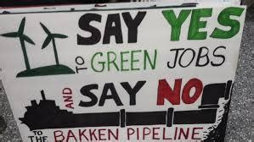

A Vision for the Future

The future is ever-changing, shaped by the actions of here and now. For Earth Strike and its proponents, the potential future is a world where humans can live in tandem with nature, rather than in a constant battle to conquer and exploit it. The barriers we have erected between humans and ecosystems shall fall away as people across all cultures build a beautiful coalition with the rest of life on Earth. Together, we will reverse the damage done by constant industrialization and ecological exploitation, by breaking down the hierarchies that exist between those that own capital and the means of life, and those who do not, those who have different pigmentations and identities, and the flora and fauna who lack their own voice. We envisage a truly sustainable future where we use the resources we can regenerate and reuse, and construct a new world society that is pleasant and safe, a new

world that supports and

sustains all life for eons to come.

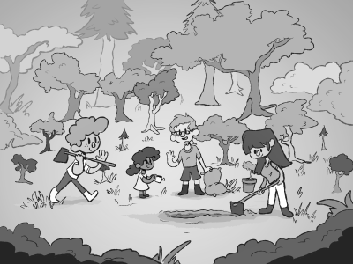This will happen through the organizing of the most powerful force in society, the working class, to take control of their labour and enact a general strike to save the planet. In solidarity with other action groups, we will all be fighting together for a sustainable future. The demands we have laid out at national, international and local levels pave the way, and serve as critical stepping stones to show those in power what we are looking for in a new world. A world where the Earth, her endless bounds and her creatures are allowed to exist as themselves, not solely as resources to be extracted and commodified.  
We recognise that we alone cannot enact these demands, with a few days spent slowing the industrial economy down with demonstrations. The system is too deeply ingrained in our lives to make this change by September. What we plan to do is set a precedent for future organizing efforts to show the power of labourers working together, build strong foundations and coalitions, and serve as inspiration for movements soon to come. Join us to help us build this future and remind the people of the world of our desire for change and power to enact it.

Our Demands

International

* An immediate start on global co-operation to reverse the damage done to the Earth’s climate, through unambiguous and binding agreements, by both world leaders and corporate entities, following IPCC projections of halving carbon net emissions by 2030 and zero net emissions by 2050.
* International, unambiguous and binding commitments to halt the destruction of rainforests and other wildlife habitats.
* International, unambiguous and binding agreements designed to hold corporations accountable for the greenhouse gases they produce.

[insert your local chapter’s demands here]

Sources

[1] “Climate Change Indicators: Atmospheric Concentrations of Greenhouse Gases.” *EPA*, Environmental Protection Agency, 23 Jan. 2017,

[2] Mgbemene, Chigbo A., et al. “Industrialization and Its Backlash: Focus on Climate Change and Its Consequences.” *Journal of Environmental Science and Technology*, vol. 9, no. 4, 2016, pp. 301–316., doi:10.3923/jest.2016.301.316.

[3] *IPCC Special Report: Global Warming of 1.5 Deg C*. Intergovernmental Panel on Climate Change.

[4 ]Dannenberg, John. “Prison Drinking Water and Wastewater Pollution Threaten Environmental Safety Nationwide.” *Prison Legal News*, Clean Water Act., [www.prisonlegalnews.org/news/2007/nov/15/prison-drinking-water-and-wastewater-pollution-threaten-environmental-safety-nationwide/](http://www.prisonlegalnews.org/news/2007/nov/15/prison-drinking-water-and-wastewater-pollution-threaten-environmental-safety-nationwide/).

[5] Griffin, Paul, and Climate Accountability Institute. “2017 Carbon Majors Report.” Carbon Majors Database, July 2017, 6fefcbb86e61af1b2fc4-c70d8ead6ced550b4d987d7c03fcdd1d.ssl.cf3.rackcdn.com/cms/reports/documents/000/002/327/original/Carbon-Majors-Report-2017.pdf?1501833772.

[6] Jackson, R B, et al. “Global Energy Growth Is Outpacing Decarbonization.” *Environmental Research Letters*, vol. 13, no. 12, 2018, p. 120401., doi:10.1088/1748-9326/aaf303.

[7] Weiss, Kenneth R. “Some of the World's Biggest Lakes Are Drying Up. Here's Why.” *National Geographic*, Mar. 2018.

[8] Vitousek, P. M., et al. “Human Domination of Earths Ecosystems.” *Science Magazine*, vol. 277, no. 5325, 25 July 1997, pp. 494–499., doi:10.1126/science.277.5325.494.

[9] Ceballos, Gerardo, et al. “Accelerated Modern Human–Induced Species Losses: Entering the Sixth Mass Extinction.” *Science Advances*, vol. 1, no. 5, 19 June 2015, doi:10.1126/sciadv.1400253.

[10] Team, ESRL Web. “ESRL Global Monitoring Division - Global Greenhouse Gas Reference Network.” *ESRL Co2 Trends RSS*, Global Greenhouse Gas Reference Network, 1 Oct. 2005, [www.esrl.noaa.gov/gmd/ccgg/trends/gl_full.html](http://www.esrl.noaa.gov/gmd/ccgg/trends/gl_full.html).

[11] Etheridge, D M, et al. “Historical CO2 Record Derived from a Spline Fit (20 Year Cutoff) of the Law Dome DE08 and DE08-2 Ice Cores.” *Carbon Dioxide Information Analysis Center (CDIAC)*, June 2019, cdiac.ess-dive.lbl.gov/ftp/trends/co2/lawdome.smoothed.yr20.

Join Us:

[insert your local chapter email and social media accounts here]

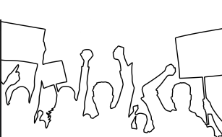

Next Day of Action: August 1st

Meet at __*protest location*___ at __*time*__

Keep Updated!

Find Earth Strike on Your Preferred Social Media: